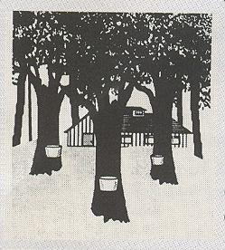

O R D E R F O R M

For the complete description of our maple products (with photos) and to know

the different ways of payment , refer to the page OUR PRODUCTS.

To order, please complete the Order Form which follows and e-mail it to us

with a message at this e-mail address : info@erabliereiledorleans.qc.ca

RETURN TO : ÉRABLIÈRE RICHARD BOILY
2977, chemin Royal
Sainte-Famille, Île d'Orléans
Québec, Canada G0A 3P0
Courriel : info@erabliereiledorleans.qc.ca
Date of the order
Your name
Your complete address
Phone number
Your e-mail

. I ORDER THE FOLLOWING PRODUCTS :
 | QUANTITY | TOTAL
MAPLE SYRUP
Fantasy Plastic Jugs
100 ml 2,50$ /each
250 ml 4,50$ /each
500 ml 8,00$ /each
1 litre 15,00$ /each
2 litres 29,50$ /each

Sealed Cans in Stainless Steel
540 ml 9,00$ /each
OTHER MAPLE PRODUCTS

Maple Butter (250g)
Regular container 5,00$ /each
Fantasy container (beige) 6,00$ /each
Granulated Maple Sugar (250g) 5,00$ /each
Sucre
Hard Maple Sugar (250g) 5,00$ /each
Soft Maple Candies
Box containing 10 candies 4,00$ /each
Box containing 20 candies 7,50$ /each
En Small plastic bag with 10 candies 2,50$ /each
Other
Postcards with scenes of maple syrup production 1,00$ /each
SUB - TOTAL =
NOTE : MAILING COSTS ARE ON EXTRA

(418) 829-2874 | info@erabliereiledorleans.qc.ca

